**Employee Login (Cashier)**

Welcome to **Employee** **Login,** here’s a simple step by step guide for the typical login process.

First, open the system’s login page. An employee should sign in by typing their username and password.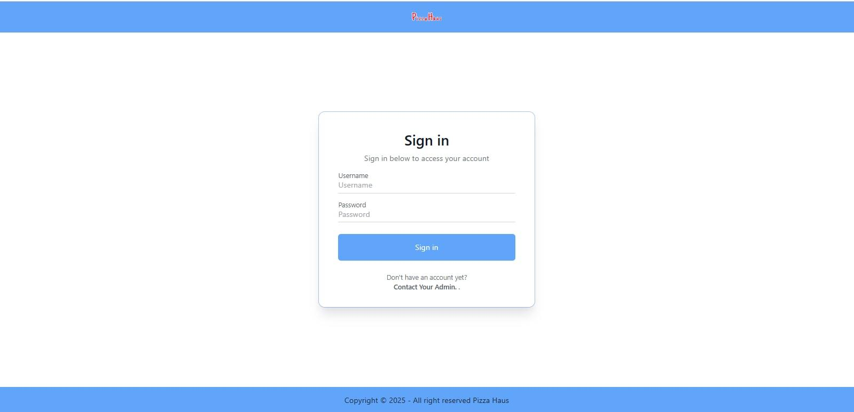

If an employee try to login and not recognize by the system it shows having an error “ Employee not found” this suggests where the entered username is checked against a database of registered employees.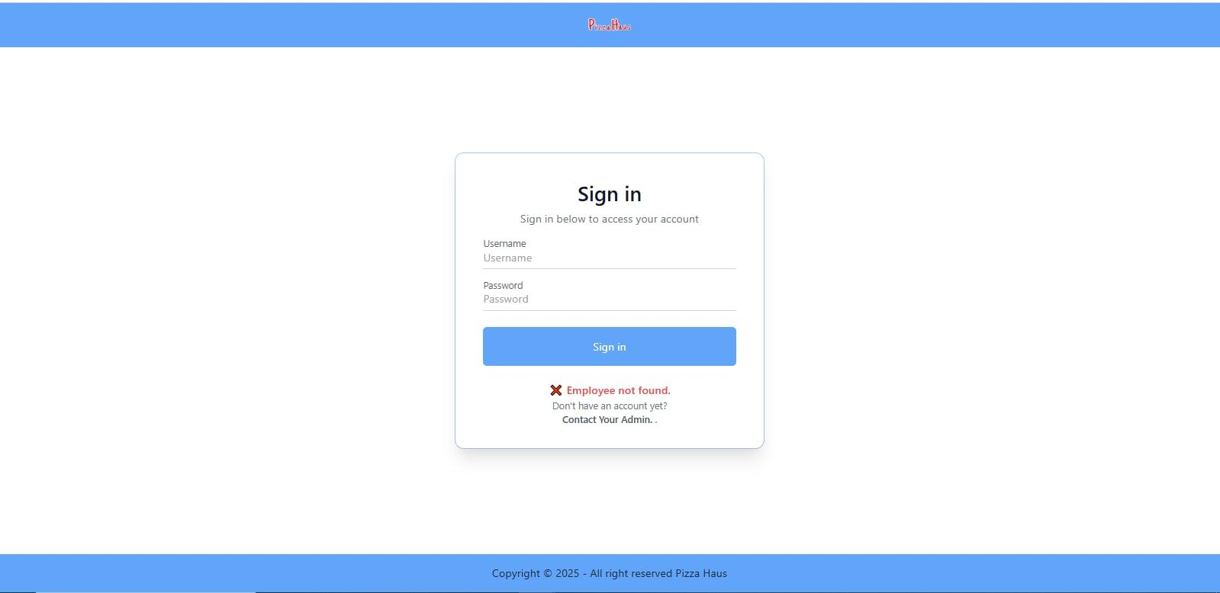

It tells the employee that both username and password need to be filled.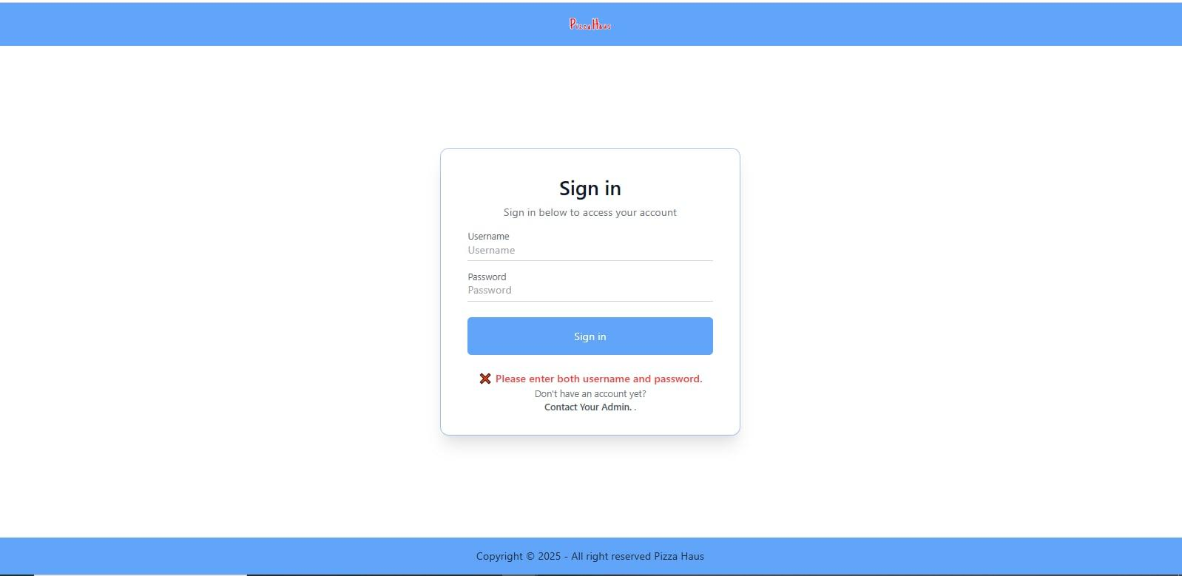

The system determines that the entered username and password is invalid. It display the error message “ Invalid username or password”. The user may re-enter their username and password ensuring they are typed correctly.

This error message guides the user how to correct the error. The system provides feedback to the user when the login fails. If the user believes their credentials are correct but the login continues to fail, they are advised to contact their administrator as indicated by the text “Don’t have an account yet?” and “Contact Your Admin”. 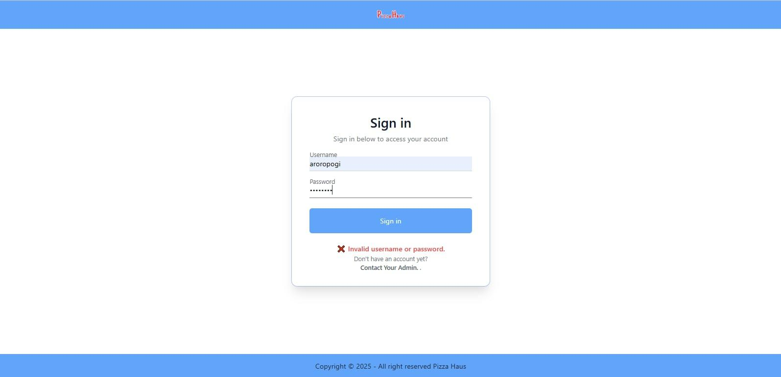

After you login in the system this page will show an “ Employee Dashboard ” that you can click any of these selection such as View Orders, Update Order Status, View Order Details, Employee Info. and Logout.

When you click on the **"View Orders"** option, the system will display a table containing order-related information. The table will include a header with the following columns: **Order ID, Customer ID, Order Date, Total Amount, Order Status,** and **Payment Status**. This data will be retrieved from the database, ensuring that users can access real-time order details. By viewing this table, users can efficiently track orders, monitor their status, and review payment information for better order management.

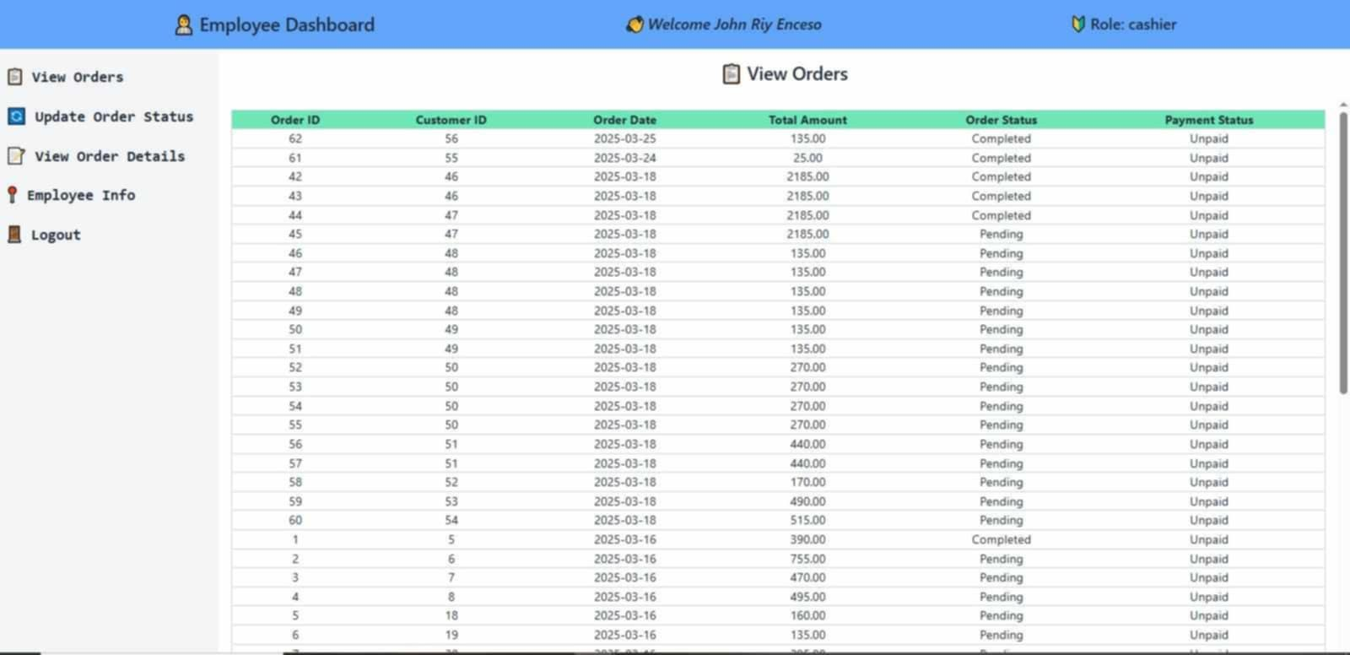

In the **View Order Details** section, the system will display essential information about each order, including the **Order Item ID**, **Order ID**, **Product ID**, **Customer Name**, **Product Name**, and **Quantity**. This data will be retrieved from the **orders** table in the database, ensuring that users can review specific details about each item within an order. By accessing this section, users will be able to track order contents efficiently and verify key information related to the purchased products.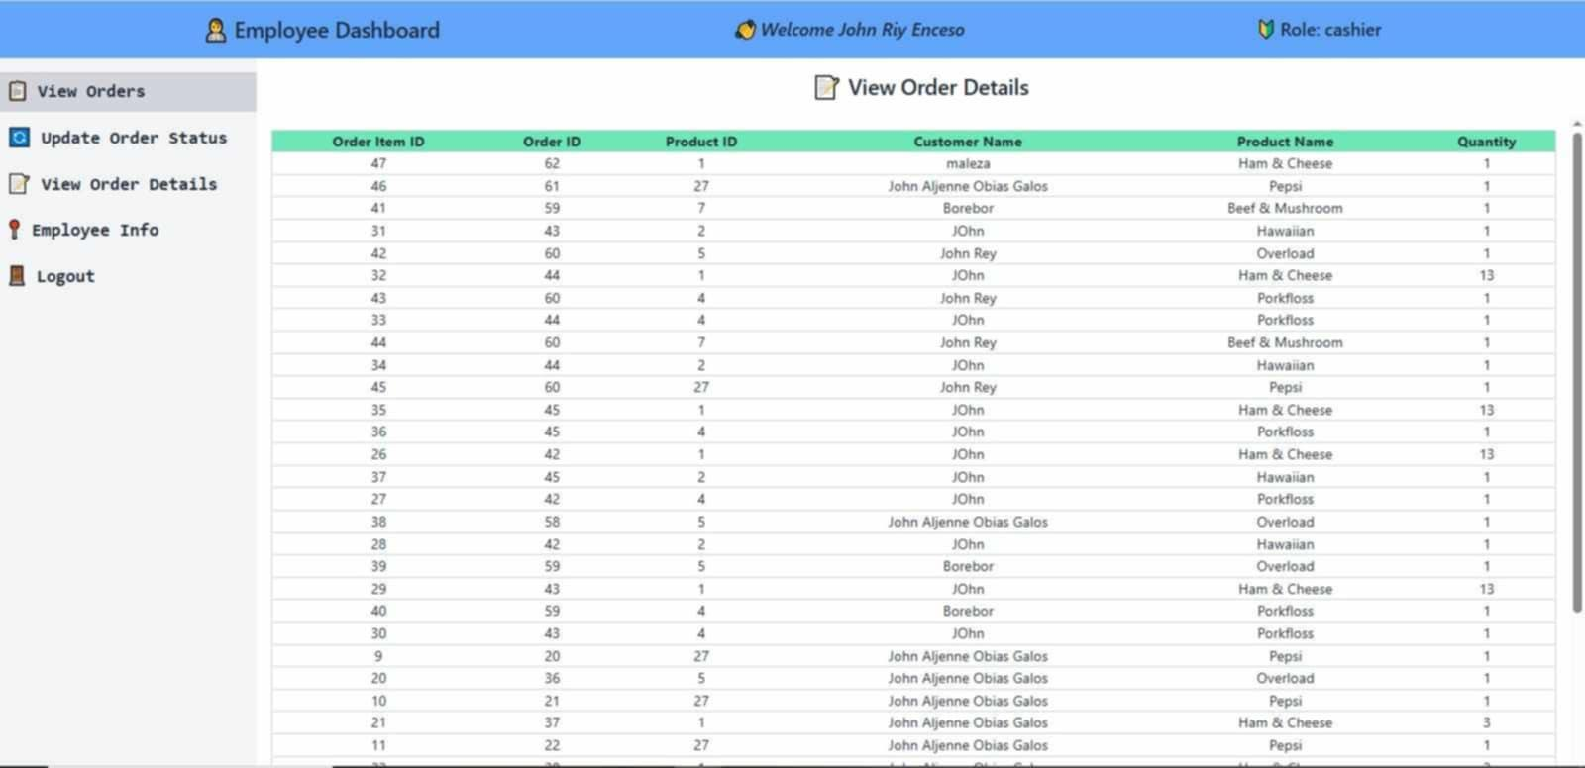

On this page, the system will display **Employee Details**, providing comprehensive information about each employee. This includes a **photograph** of the individual, along with their **Employee ID, contact information, role, employment details,** and **current status**. By presenting this data, users can quickly identify employees, review their roles and responsibilities, and access key employment-related details. The inclusion of photographs enhances recognition, making it easier to manage and verify employee records efficiently.

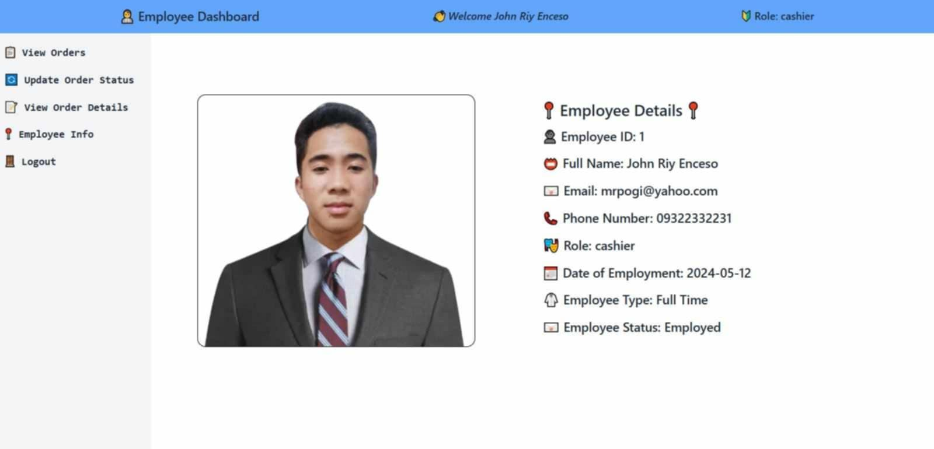

The **"Update Order Status"** feature allows users to modify the status of an existing order. On this page, users will first be presented with a field to select an **Order ID**, where they can choose a specific order, such as **Order ID**. After selecting the order id, they will be able to update its status by choosing from the available options in the **New Status** dropdown menu, which includes **Pending, Completed,** and **Cancelled**. This functionality ensures accurate order tracking and management by keeping order statuses up to date in the system.

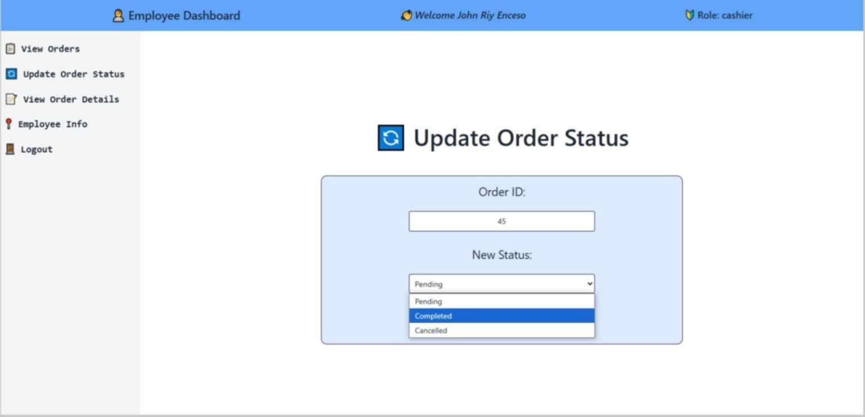

An employee is allowed to **update the order status** by marking it as **“Completed”** if the customer's order has already been processed. This ensures that the system accurately reflects the current state of the order. By selecting the **"Completed"** status, employees can confirm that the order has been successfully fulfilled and is ready for delivery or pickup.

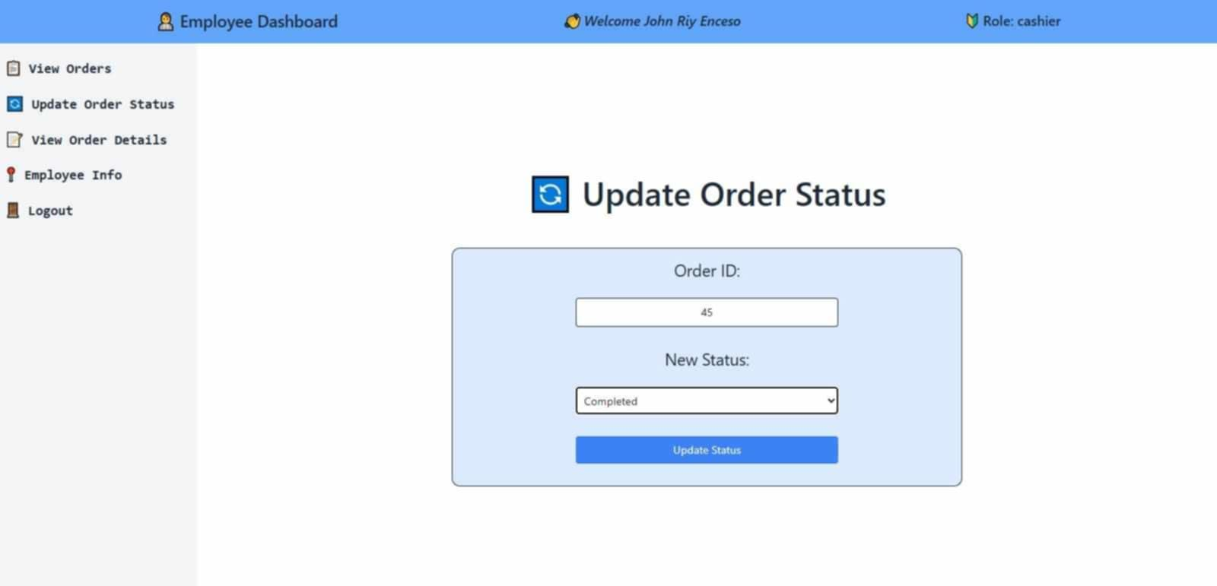

Before an order is marked as **“Completed,”** it is typically in a **“Pending”** status, which indicates that the customer's order is still being processed. The **Pending** status helps employees track orders that are still in progress and ensures that only fully processed orders are marked as **Completed**. This step-by-step status update improves order management, reduces errors, and provides a clear workflow for handling customer purchases efficiently.

If the order was **Canceled**, the record would be updated to reflect **Canceled** rather than **Completed.**

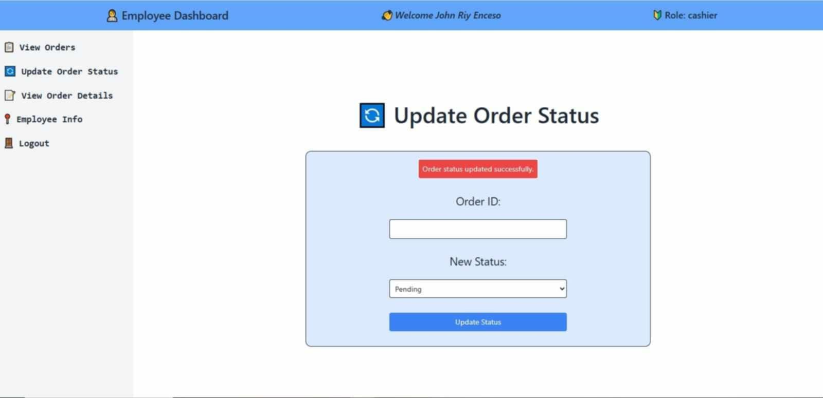

After selecting **"Update Order Status,"** the updated status will be **recorded and reflected** in the **"View Orders"** section. This ensures that any changes made to an order's status, such as updating it from **Pending** to **Completed** or **Cancelled**, are accurately stored in the database and displayed in the order records. By keeping the **View Orders** page updated, employees can easily track the latest order statuses, ensuring smooth order management and transparency in the system. 